1. A help desk technician is troubleshooting Wi-Fi connectivity issues on a user's mobile phone. Restarting the phone and router did not resolve the issue.

Which next step should a help desk technician take to attempt to resolve the issue?

**A.** Reset the network settings to default.

**B.** Replace the SIM card.

**C.** Ensure that airplane mode is off.

**D.** Update the OS to the latest version.

1. 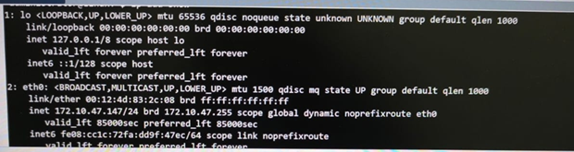

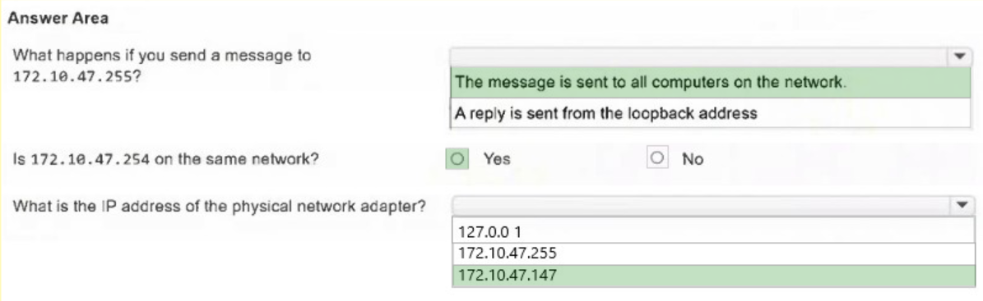

1. You need to help a Windows user close some Microsoft Edge pages that are no longer responding.

You guide them to Task Manager to perform the action.

In the answer area, select the tab that will allow the user to close a task.

***Note:*** There might be multiple ways to complete this action.

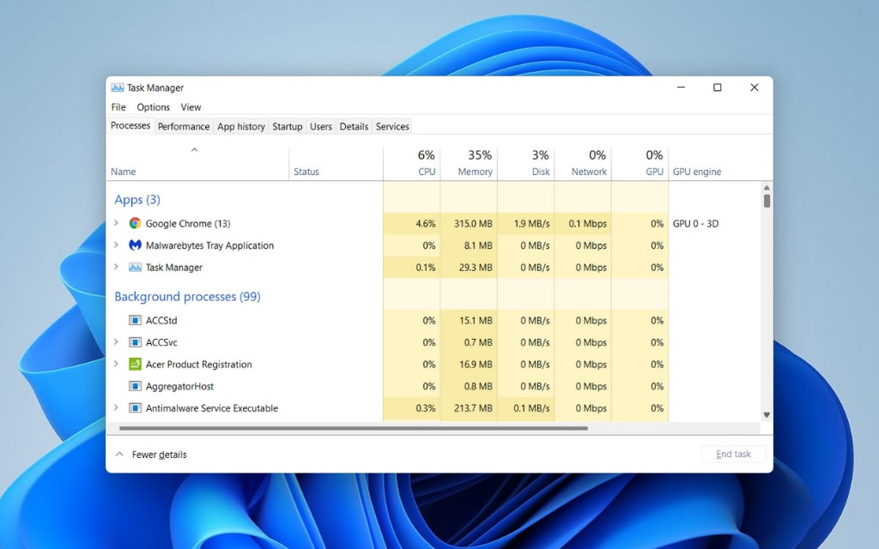

1. A user reports that they have not been able to connect their phone to the WLAN since updating it. For each condition, select **True** if the condition could relate to the issue or **False** if the condition has no relationship to the issue.

| **Condition** | **Yes** | **No** |
| --- | --- | --- |
| The phone is in Airplane Mode. | **[X]** |  |
| The phone is on a different carrier network. |  | **[X]** |
| The phone's personal hotspot option is turned off. |  | **[X]** |

1. Which password is most secure?
2. oNOm@topoeia
3. IL0veP@nc@Ke$
4. zxcvbnm,.?
5. Jonathan1!
6. A user is trying to install a productivity application by downloading it from the vendor's website. A user account control message prompts them for administrative login. They do not have administrator credentials.

What should you do?

**A.** Tell the user to download the application from a 3rd-party Appstore.

**B.** Tell the user to submit an IT ticket to get approval for the application.

**C.** Give the user an administrator password to enter in the prompt.

**D.** Tell the user to continue with the installation using their user account password.

1. An employee is struggling with using Google Drive for storing Microsoft Office files that they create and edit on their PC using custom templates. Company policy encourages all employees to store their files on Google Drive, which is available as part of the company's Google Workspace subscription.

What should you recommend to help the employee more easily manage files on Google Drive?

**A.** Recommend that the user stop using Microsoft Office and only use Google Workspace apps.

**B.** Instruct the employee to download and install Google Drive for Desktop.

**C.** Use Airdrop to transfer and download the files from Google Drive.

**D.** Have the employee upload all edited and new files to Google Drive at the end of each workday and then download the required files for editing as needed.

1. 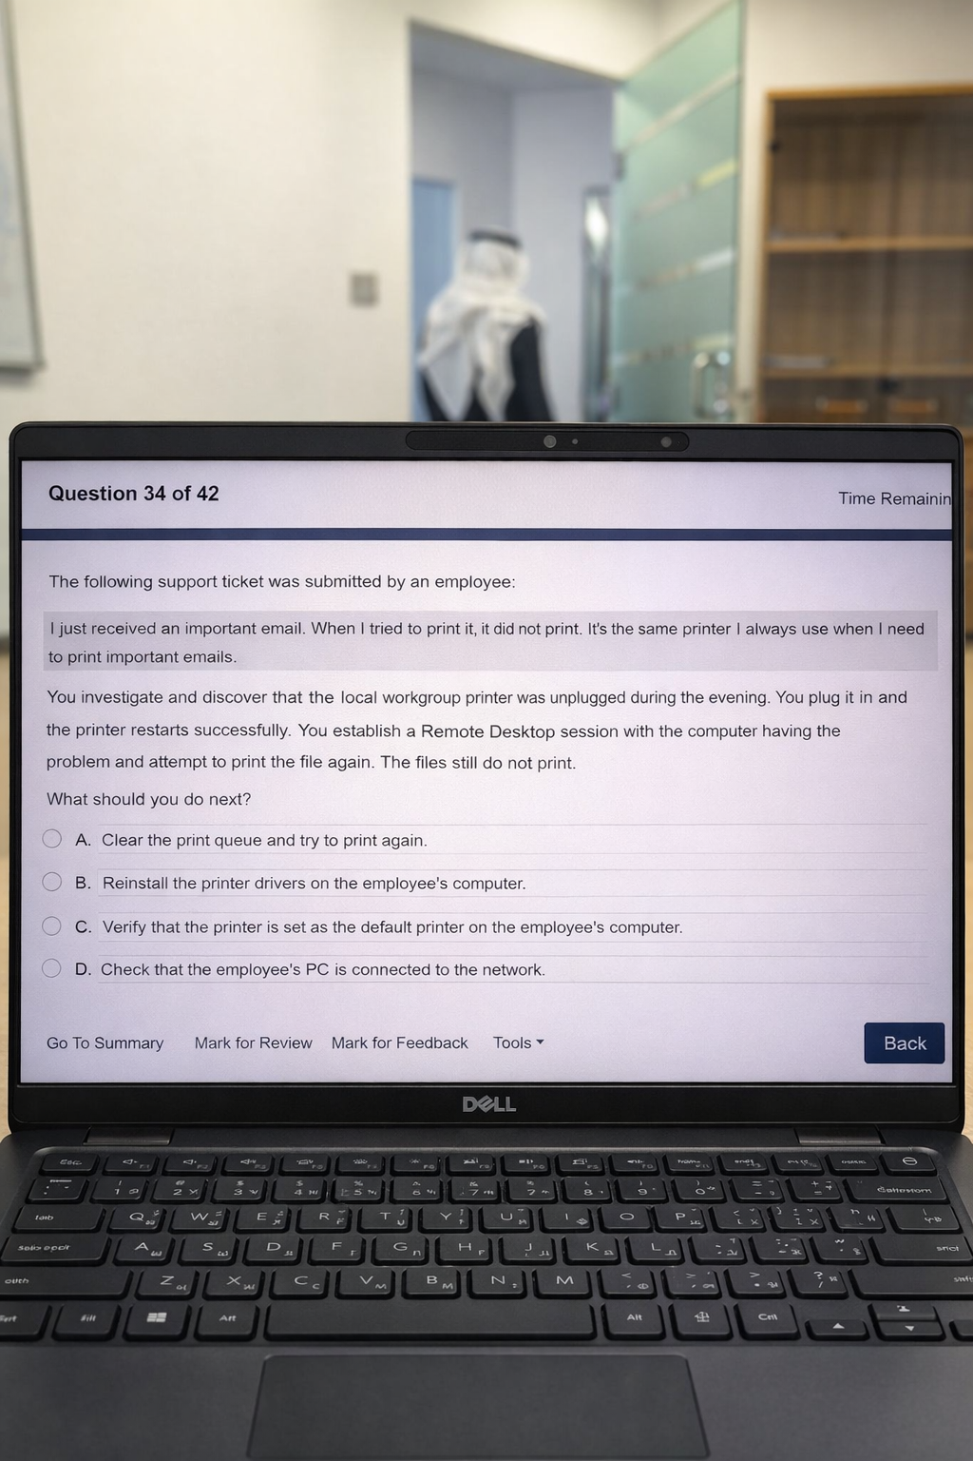The following support ticket was submitted by an employee:

You investigate and discover that the local workgroup printer was unplugged during the evening. You plug it in, and the printer restarts successfully.

You establish a Remote Desktop session with the computer having the problem and attempt to print the file again. The files still do not print.

What should you do next?

**A.** Clear the print queue and try to print again.

**B.** Reinstall the printer drivers on the employee's computer.

**C.** Verify that the printer is set as the default printer on the employee's computer.

**D.** Check that the employee's PC is connected to the network.

1. Which IPv6 address would be assigned by DHCPv6 to a host that needs to reach IPv6-only resources on the internet?
2. 2001:1db8:1234::1
3. fe80: b1e8:6ee4:1f37:af98
4. fd4c: 3456:0012a::1
5. ff05::ff
6. A help desk technician is using Windows Device Manager to troubleshoot a hardware issue reported by a user. Which indicator identifies a device that might be malfunctioning?

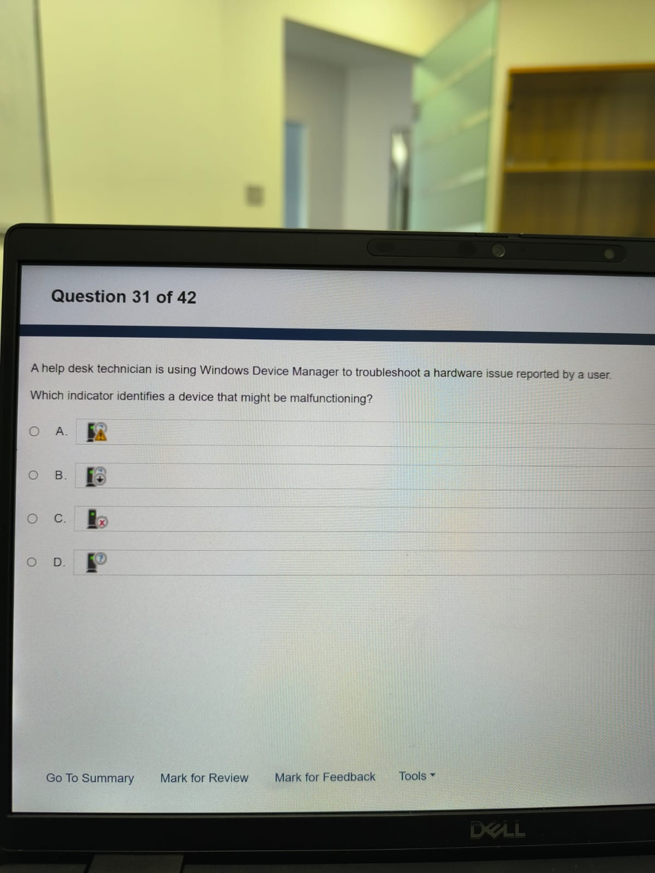

1. You need to provide remote technical support to a colleague who is encountering computer issues while working from home on their Windows 11 computer. The colleague needs you to troubleshoot and resolve the problem while they are at lunch.

Which remote access software option allows direct control of the end user’s device without requiring the user to be present?

**A.** Remote Desktop

**B.** Virtual Network Computing (VNC)

**C.** Remote Assistance

**D.** Cisco WebEx

1. You connect with a client over WebEx. You can hear the client speaking but they cannot hear you. Which three things should the client check to get the audio working properly? (Choose 3.)

***Note:*** You will receive partial credit for each correct selection.

1. The input volume is turned up.
2. The sound isn't being muted.
3. The operating system volume is turned up.
4. The microphone icon is not selected.
5. The correct sound device is selected in WebEx.
6. The line in property is not disabled.
7. 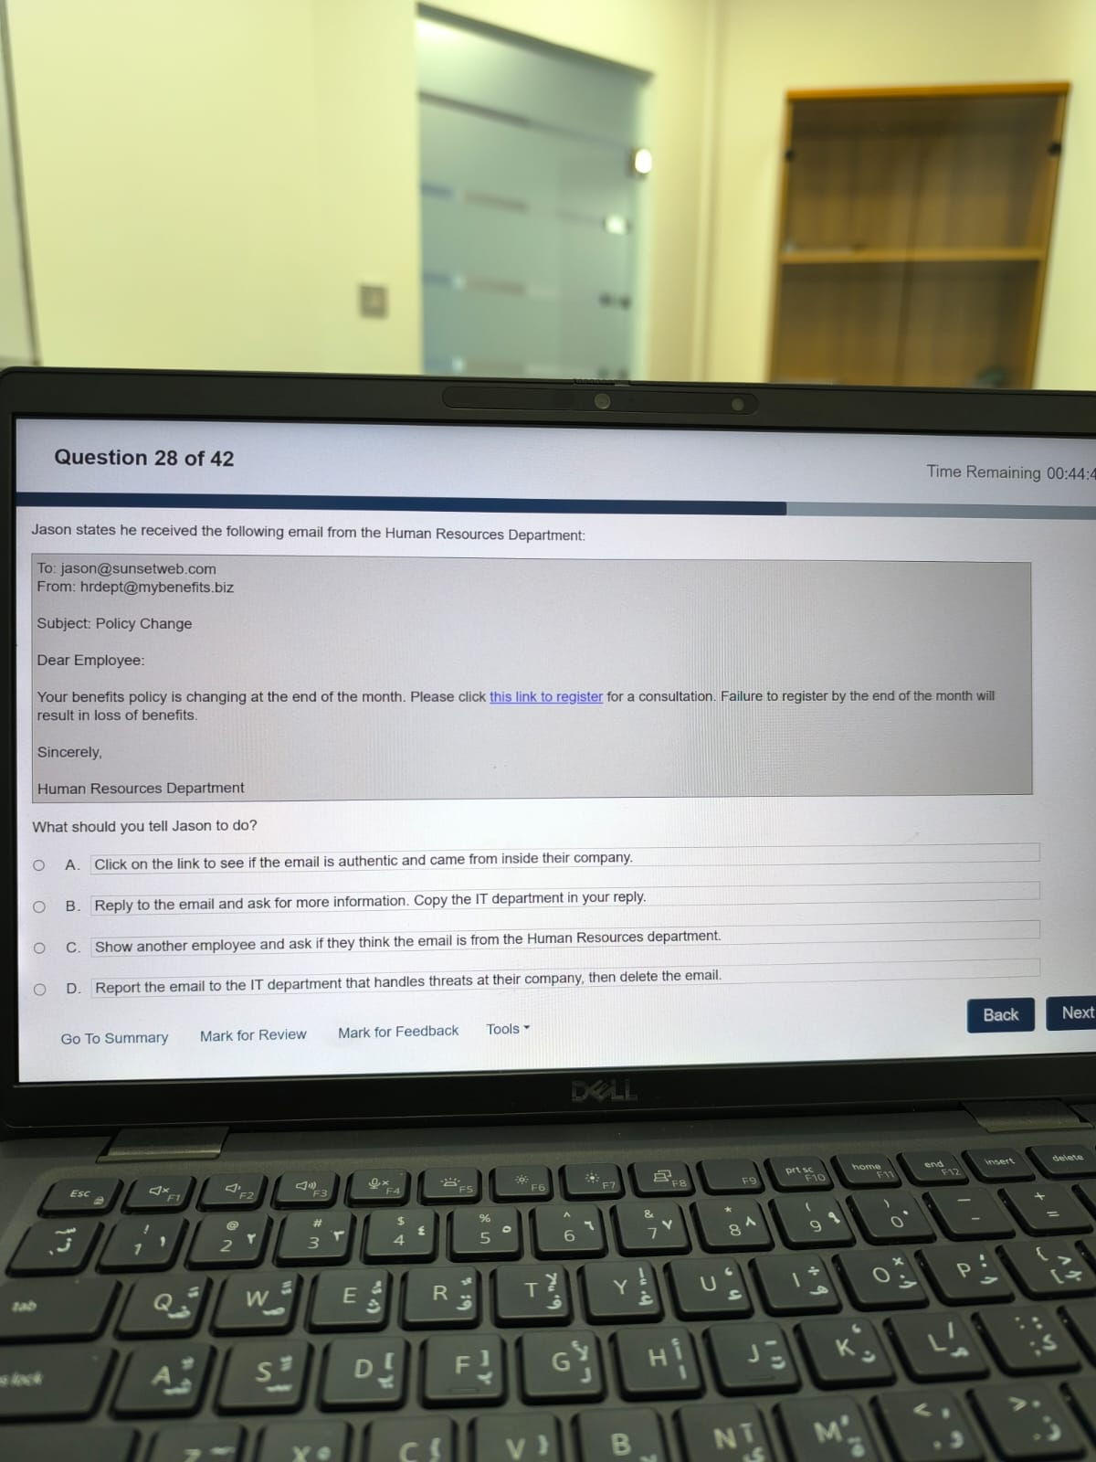Jason states he received the following email from the Human Resources Department:  
   What should you tell Jason to do?

**A.** Click on the link to see if the email is authentic...

**B.** Reply to the email and ask for more information...

**C.** Show another employee and ask if they think the email is from HR.

**D.** Report the email to the IT department that handles threats at their company, then delete the email.

1. You are investigating a DNS problem. Which command can you use to query DNS records from a command-line interface?
2. traceroute
3. ping
4. nslookup
5. netstat
6. A customer complains that the performance of their PC is severely impacted when several applications are open at the same time. You suspect that a memory upgrade might fix the problem. You need to determine whether a memory upgrade is necessary.

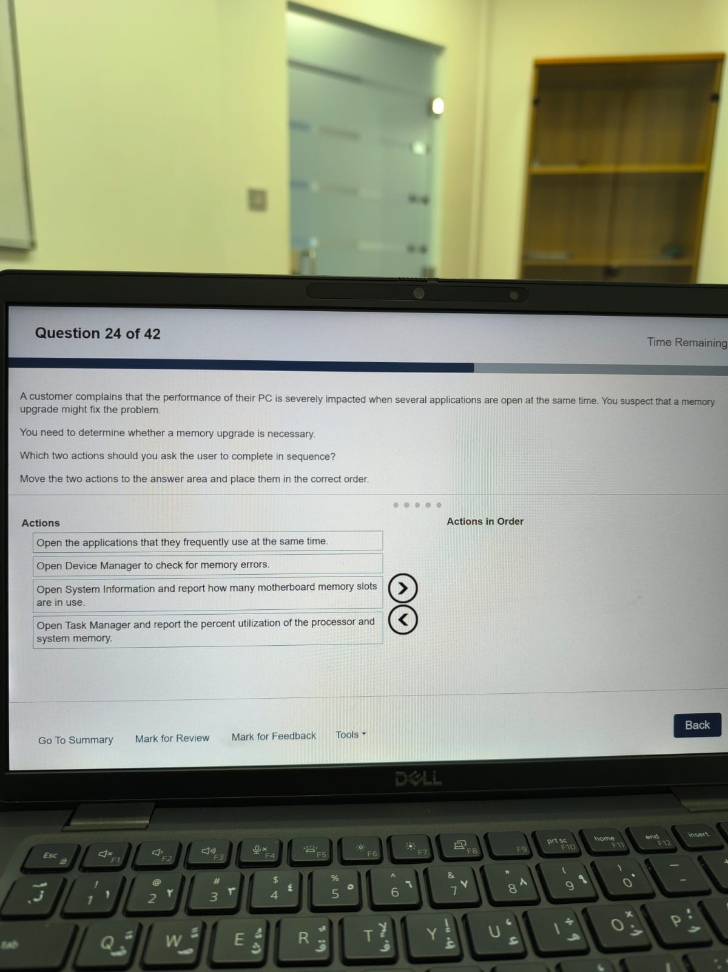Which two actions should you ask the user to complete ***in sequence***?

**Actions in Order :**

1. Open the applications that they frequently use at the same time.
2. Open Task Manager and report the percent utilization of the processor and system memory.
3. You receive a phone call from a customer who reports they are unable to print. They have already tried printing a test page with no success. They indicate that the printer icon in the taskbar says the job is pending. You suspect that the networked printer is unavailable.

What should you do next?

**A.** Tell the user to print to a different printer.

**B.** Ask the user which applications they are trying to print from.

**C.** Replace the printer with one that works.

**D.** Test the printer's network connectivity.

1. You are a help desk technician at Healthy Eats. The company has 1000 employees in multiple locations. An end user calls you via telephone and states the following:

What should you do?

1. Reset the password because Jane Doe has to process payroll immediately.
2. Request Jane Doe's call back number so that you can reset the password and call Jane Doe back to verify the reset was successful.
3. Call Jane Doe's manager using their company number to verify Jane Doe's needs and identity.
4. Ask Jane Doe for their email address so that you can email them to verify identity.
5. Company policy states that all sensitive PII will be removed from company servers after 3 months of inactivity. A user requests verification that their data was removed after this date. You check the server and there is still user data present, but the removal was successful. Which data should have been removed?

**A.** Full Name

**B.** Phone Number

**C.** Physical Address

**D.** Email Address

**E.** Driver's License Number

1. A technician needs to upgrade the CPU of a user's desktop computer. The technician opens the computer and sees the internal components. Which letter identifies the component you need to remove to locate the CPU?  
   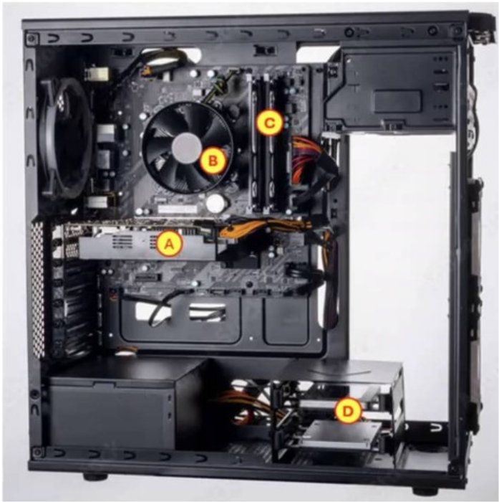

**A.** A

**B.** B

**C.** C

**D.** D

1. Which three individual pieces of information are personally identifiable information (PII) and should be protected to safeguard an individual's privacy? (Choose 3.)  
   **Note:** You will receive partial credit for each correct selection.

**A.** Language preference

**B.** Social Security Number (SSN)

**C.** Email address

**D.** Place of birth

**E.** Credit card number

**F.** First name

1. A user reports that they just added a second monitor to their computer, but they are seeing the same image on both screens. Each monitor is plugged directly into a separate HDMI port on the computer. The user wants to be able to view different documents on each monitor. Which display mode should they configure?

**A.** Duplicate these displays

**B.** Extend these displays

**C.** Show only on 1

**D.** show only on 2

1. You consider using AI to find solutions to common Help Desk issues at your company. For each statement about AI, select **True** or **False**.

| **Condition** | **True** | **False** |
| --- | --- | --- |
| Predictive AI uses historical data to forecast future outcomes. | **[X]** |  |
| Generative AI creates new content based on trained, unstructured data. | **[X]** |  |
| Generative AI is more reliable than predictive AI. |  | **[X]** |

1. 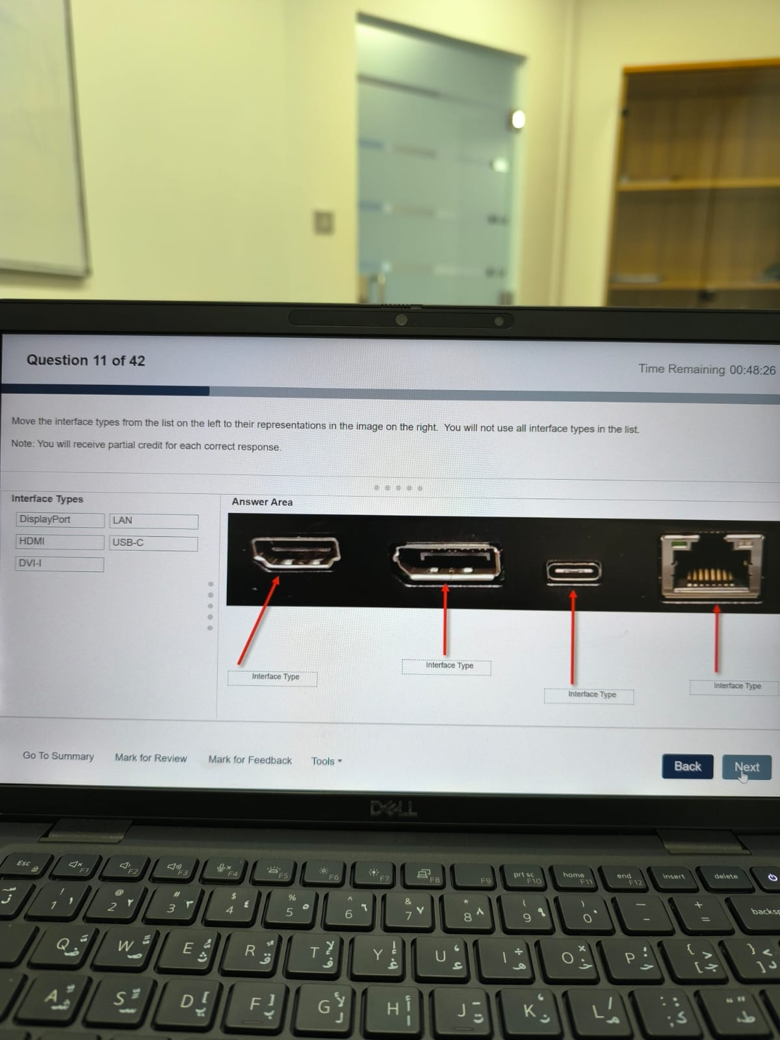Move the interface types from the list on the left to their representations in the image on the right. You will not use all interface types in the list.   
   HDMI, DisplayPort, USB-C, LAN
2. A MacOS user needs help closing some Safari processes that are no longer responding. Which option will close the processes in Activity Monitor?
3. End Task
4. Force Quit
5. Force Stop
6. End Process
7. What is the purpose of a queue management system for a help desk?

A. It allows clients to choose their place in the queue.

B. It ensures that customer issues are addressed fairly and timely.

C. It ensures that customer issues are addressed based only on issue complexity.

D. It allows technicians to choose which ticket they want to complete.

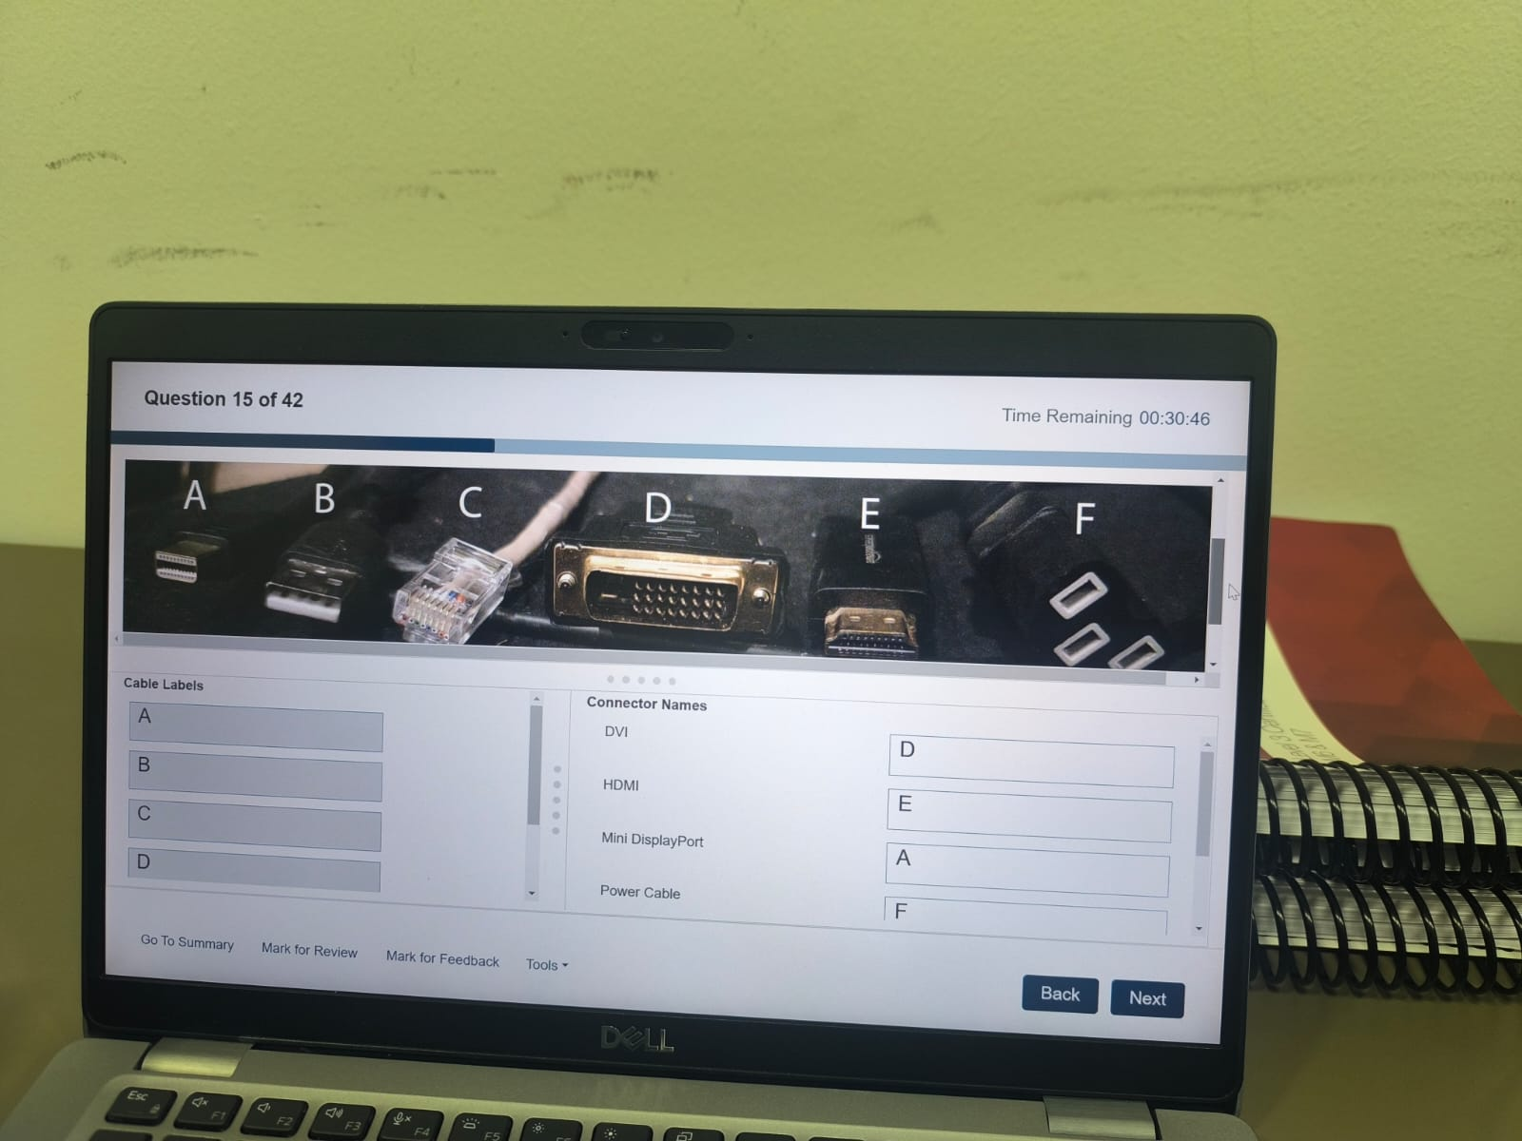

Mini DisplayPort, USB-A, RJ-45, DVI,HDMI,Power Cable

1. Move each Windows tool from the list on the left to its description on the right.

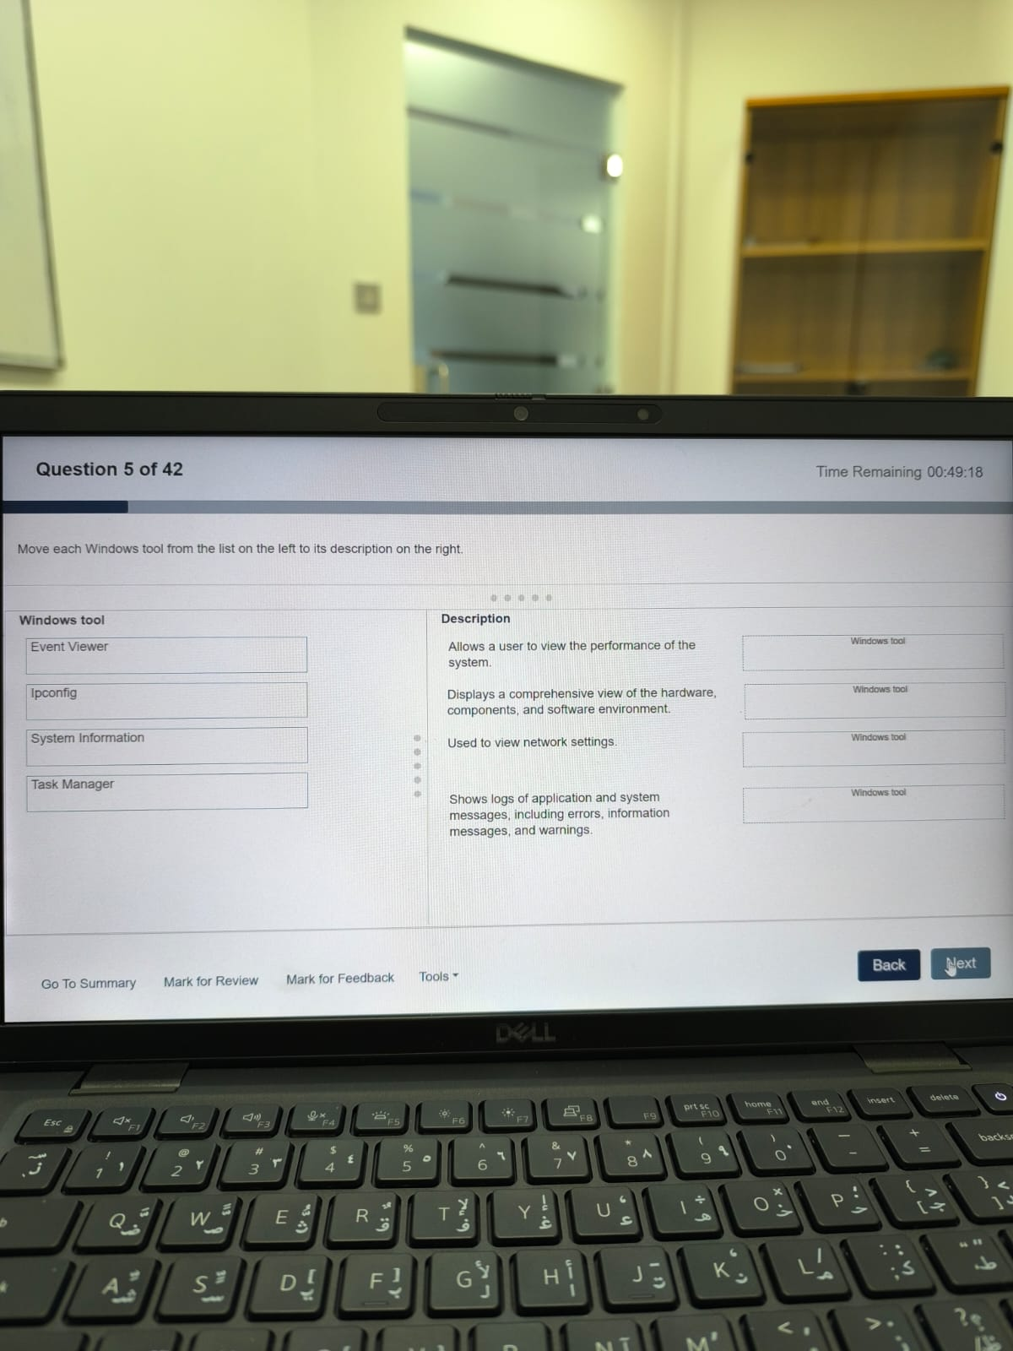

Event Viewer

Ipconfig

System Info.

Task Manager

1. A user reports that a Windows application is frozen. Which three methods can you use to direct

the user to open a tool that can be used to close the application. (Choose 3.)

**A.** Right-click on the taskbar and choose Task Manager.

**B.** Right-click on the desktop and choose Task Manager.

**C.** Press Ctrl-Shift-Esc on the keyboard.

**D.** Press Ctrl-Alt-Esc on the keyboard.

**E.** Right-click the Start icon and choose Task Manager.

1. A user calls the help desk and states that their computer crashes every time they use a specific application. What should be your initial response to the user?

**A.** Provide the user with alternative applications to use until the issue resolves itself.

**B.** Ask the user to restart their computer.

**C.** Ask the user to provide detailed information about actions leading up to the crash and error messages displayed.

**D.** Ask the user to stop using the application until a software update is released by the company.

1. Which two operating systems support Remote Desktop client connections? Note: You will receive partial credit for each correct selection.

**A.** Windows 11 Pro

**B.** Windows 10 Enterprise

**C.** Windows 11 Home

**D.** Windows 10 Home

1. Which action must a service desk technician take to resolve a printer driver failure on a desktop PC?

**A.** Update the device driver software.

**B.** Disconnect and reconnect from the power source.

**C.** Move the driver file to the C:\Windows\System32 folder.

**D.** Boot the computer in safe mode.

1. Match each Windows tool from the list on the left to its appropriate usage scenario on the right.

|  |  |  |  |
| --- | --- | --- | --- |
| **Device Manager** | **Disk Management** | **Display Settings** | **Task Manager** |

| **Usage Scenario** | **Windows Tool (Matched)** |
| --- | --- |
| The technician is helping a user set up multiple monitors so they can work more efficiently. | **Display Settings** |
| The technician advises a user on how to prepare a new external hard drive for file backup by formatting it and assigning a drive letter. | **Disk Management** |
| To address complaints of a sluggish computer, the technician guides the user through identifying programs that are consuming too much system resources. | **Task Manager** |
| A user is having trouble with their newly connected webcam not functioning correctly, and the technician needs to verify the driver installation. | **Device Manager** |

1. A user reports that they are having issues connecting devices to any USB port on their windows laptop. You need to tell the user how to check the USB ports for errors.

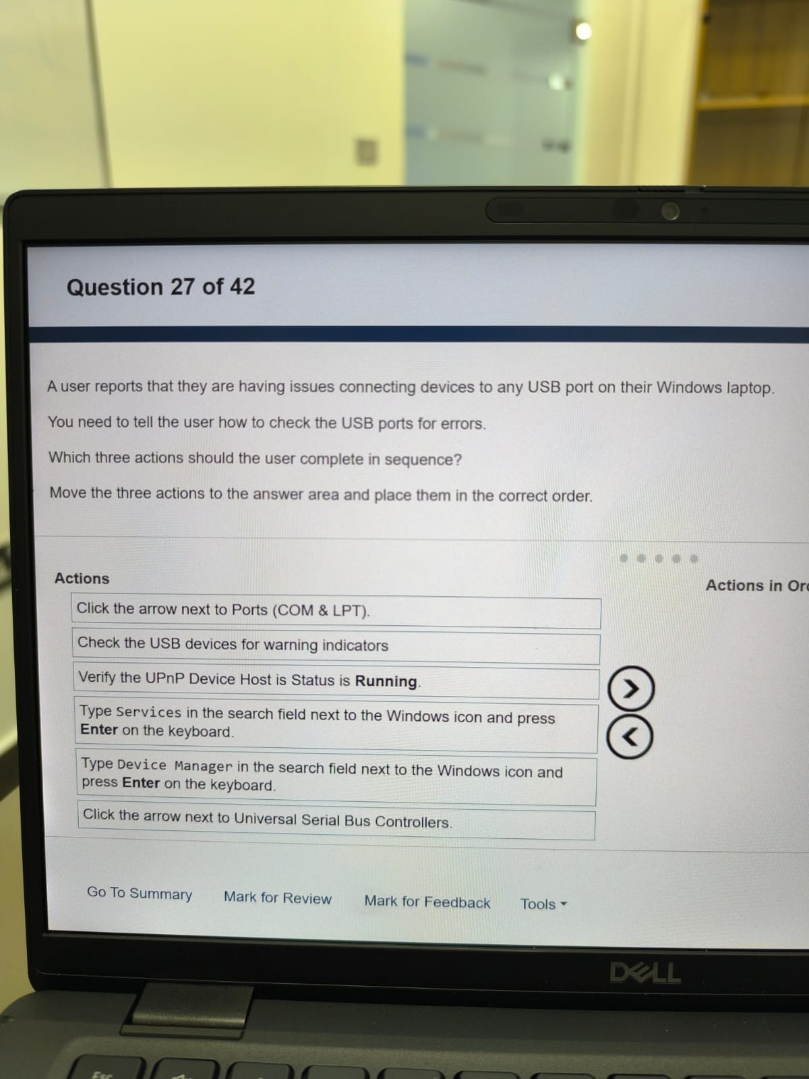Task: Which three actions should the user complete in sequence? Move the three actions to the answer area and place them in the correct order.

Correct Answer (Actions in Order):

1. Type Device Manager in the search field next to the Windows icon and press Enter on the keyboard.
2. Click the arrow next to Universal Serial Bus Controllers.
3. Check the USB devices for warning indicators.
4. 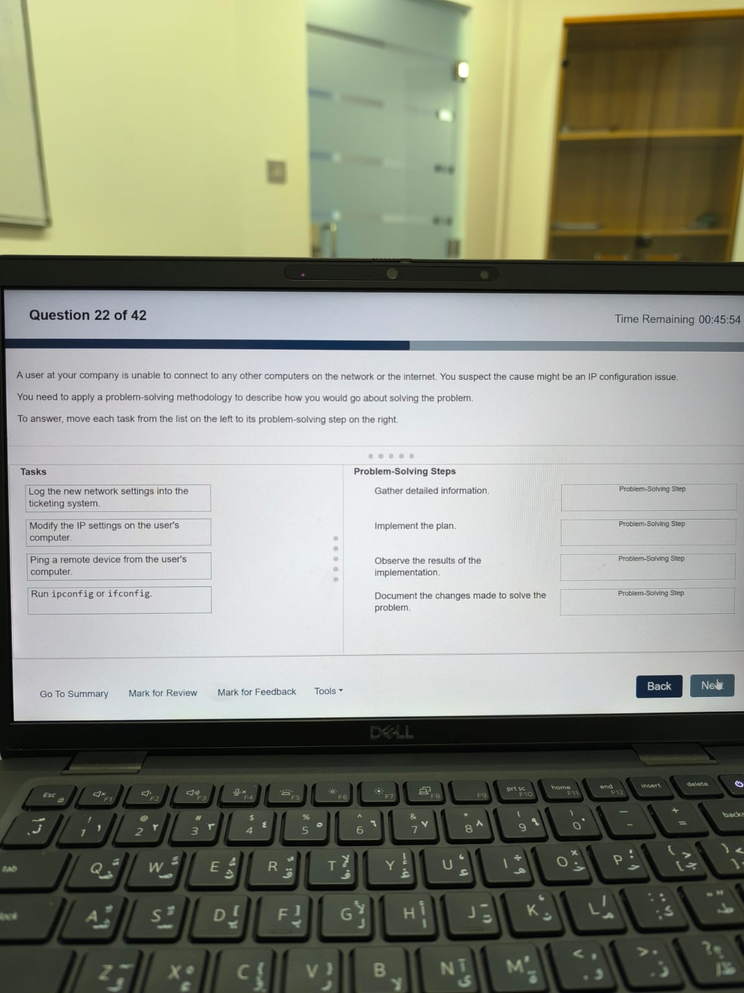A user at your company is unable to connect to any other computers on the network or the internet. You suspect the cause might be an IP configuration issue. You need to apply a problem-solving methodology to describe how you would go about solving the problem. To answer, move each task from the list on the left to its problem-solving step on the right.

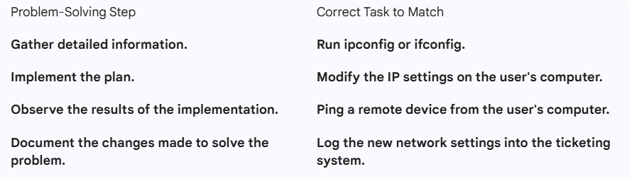

1. Which three steps are part of the problem-solving process? (Choose 3.)
2. Narrow the number of potential causes to create an efficient action plan.
3. Create an abstract problem statement.
4. Define the problem.
5. Gather the facts to isolate possible causes.
6. Avoid isolating possible causes.
7. Expand the number of potential causes to create an efficient action plan.
8. John Douglas called the help desk because he is unable to view the Test.docx file on his mapped network drive. He can access other files on the drive. The owner of the file indicates that they gave John access.

Which setting was misconfigured?   
Select the misconfigured setting in the answer area.

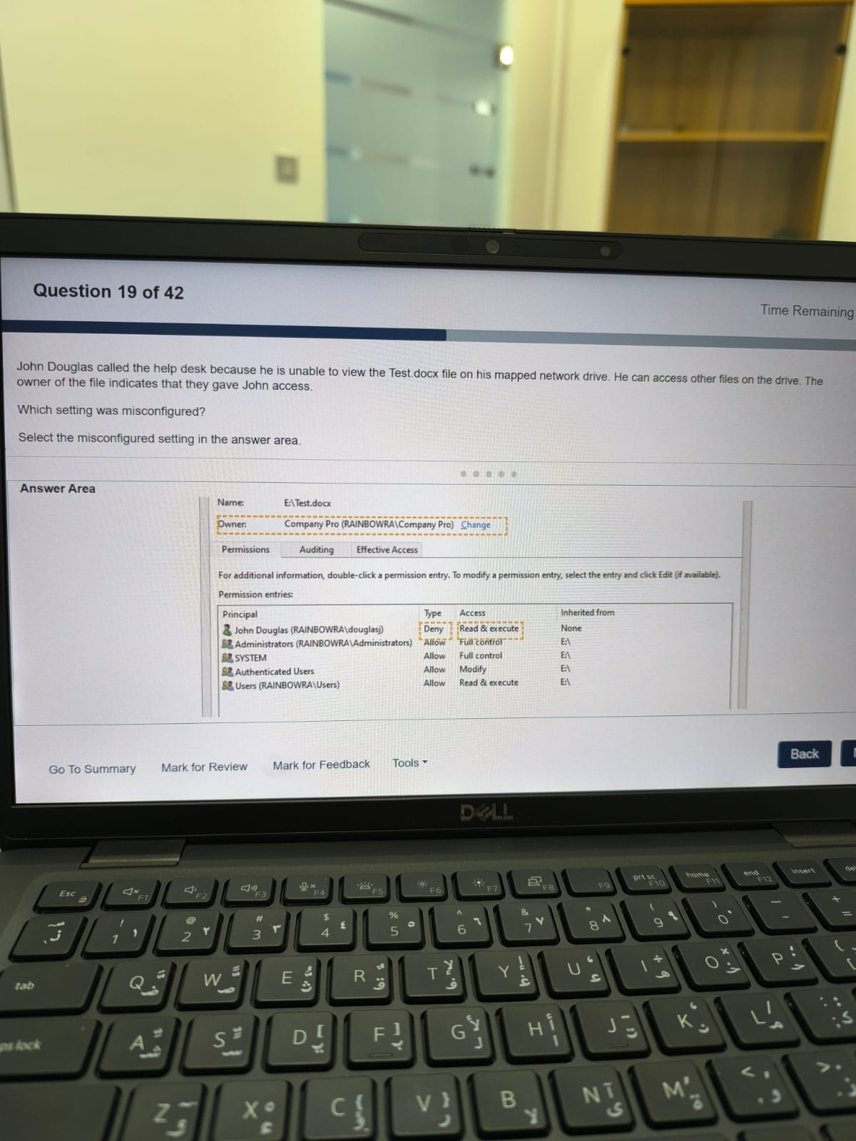

1. You receive a call from someone claiming to work in your company's networking department. This person attempts to persuade you to use the Wi-Fi details they provide. You suspect an attempted impersonation attack. Which type of impersonation attack is the person attempting?
2. Smishing attack
3. A Man-in-the-Middle attack.
4. Cousin Domain attack
5. An Account Takeover
6. A new employee at your company has just finished being onboarded. She contacts you and complains that her virtual machine is very slow. You suspect that her machine needs more resources allocated to it.

How can the virtual machine be configured with more resources?

1. Resources can be added from within the virtual machine.
2. Resources can be added from the hypervisor software.
3. Resources are not configurable after a virtual machine is provisioned.
4. Resources can be added from either the hypervisor software or from within a virtual machine.
5. A user needs assistance configuring Microsoft Teams so that it will start automatically.

Which category in Teams should the user select to set the application to auto-start?"

**A.** Accounts and orgs

**B.** General

**C.** Notifications and activity

**D.** Accessibility

1. A customer calls the Help Desk and reports the following:

I keep getting an error that my system is low on memory when I run my video editing software

Which process will allow the customer to locate the available memory of their device?

**A.** Ask the customer to open Command Prompt and type in ipconfig/all and press Enter.

**B.** Ask the customer to open Settings and select the Devices tab.

**C.** Ask the customer to open Task Manager and select the Performance tab.

**D.** Ask the customer to open Event Viewer and select the Applications and Services Log tab.

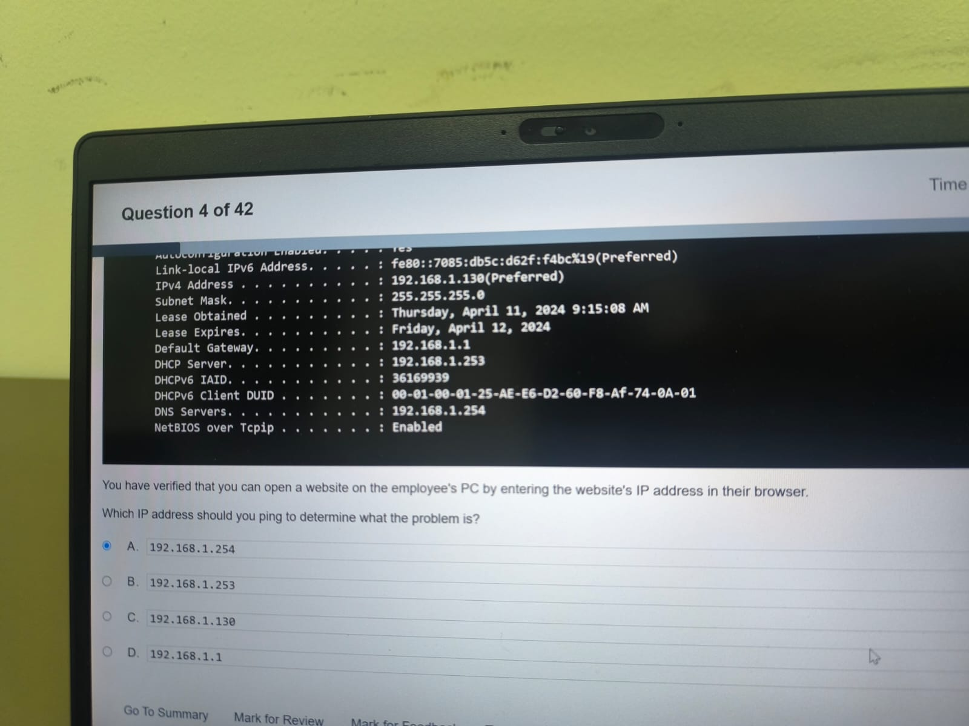  
  
You have verified that you can open the website on the employees PC by entering the website’s IP address in their browser.

Which IP address should you Bing to determine what the problem is?

**A.** 192.168.1.254

**B.** 192.168.1.253

**C.** 192.168.1.130

**D.**192.168.1.1

| **Action** | **Answer** |
| --- | --- |
| Offload unused apps. | **Yes** |
| Empty the Recently Deleted album. | **Yes** |
| Enable Optimize Photos. | **Yes** |

1. A user has low storage on an iPhone. You need to tell the user how to increase available storage.   
   For each action, select Yes if it helps the user increase available storage, or No if it does not.

1. Which type of virtualization allows a user to run one or multiple operating systems that are stored remotely on a central server in a data center?
2. Network Virtualization
3. Data Virtualization
4. Desktop Virtualization
5. Storage Virtualization
6. A customer support representative receives an email from a client that contains their full name, address, and credit card details and a request to update their billing information.

Which action should the representative take?

A. Store the data in encrypted storage.

B. Openly share the information with the accounting department.

C. Print the message and personally deliver it to the accounting department.

D. Store the data on a personal device.

1. Why does a company use Mobile Device Management (MDM)?

**A.** To allow the company to access the user's personal data.

**B.** To track the user's location when at work or traveling for business.

**C.** To ensure that mobile devices comply with company policy before accessing the network.

**D.** To authenticate users using an authenticator app on a mobile device.

1. A help desk technician is assisting a customer with setting up access from their windows computer to a shared company folder.

What should the technician do?

A. Choose a drive letter and specify the path to the shared folder.

B. Disable the antivirus software temporarily.

C. Modify the user's account to have administrative privileges.

D. Change the network profile to public.

1. You resolve a customer's printing issue. How should you document the incident?"

A. Printer is now printing. Issue is resolved and customer is happy.

B. Printing issue resolved. Ticket Complete.

C. Printing issue is resolved. Reinstalled printer drivers and rebooted computer.

D. This customer was using the wrong printer and did not know which printer they should use.

1. A customer reports the following problem:

'I purchased a 256 GB USB drive to use for transferring files from my personal computer to my work computer. My personal computer runs Sonoma. My work computer runs Windows. I can copy files from my work computer to the USB drive. However, I cannot copy files from my personal computer to the USB drive.'

What should the customer do to solve this problem?

**A.** Defragment the USB drive.

**B.** Run diagnostics on the USB drive to determine if the file system is corrupt.

**C.** Return the USB drive for a replacement.

**D.** Format the USB drive with exFAT file system.

1. A Windows user reports the following:  
     
   The computer is a member of an Active Directory domain. You open Active Directory Users and Computers.

I have tried logging into my windows computer with my password several times, but I can't log on.

For each statement, select True if it is a method the technician can use to resolve the login issue or False if the method will not resolve the problem.

***Note:*** You will receive partial credit for each correct selection.

| **Statement** | **True** | **False** |
| --- | --- | --- |
| In the user account properties, select **Password never expires**. |  | ◯ |
| **Unlock the user account** and have them try their password again. | ◯ |  |
| **Reset the user's password**. | ◯ |  |
| Select **User must change password at next logon**. |  | ◯ |

1. There are several ethical considerations involved when choosing to use artificial intelligence (AI).

What does the term transparency refer to in relation to those ethical considerations?

1. Ensuring AI is applied across a wide spectrum of diversity.
2. Implementing controls to ensure that AI solutions work as intended to help prevent inappropriate use.
3. Informing a customer when AI is being used to make a decision that could affect them.
4. Using privacy controls to ensure that personal data usage is allowed.
5. Which three practices help create clear, concise, and factual documentation for an IT help desk ticket? (Choose 3.) Note: You will receive partial credit for each correct response.

A. Add resolution details.

B. Collect personal data for later identity verification.

C. Write a detailed description of the problem in the ticket body.

D. Assign a category.

E. Write a summarized description of the problem in the ticket body.

1. A customer has the following issue:

I cannot access files from my external disk drive on my Windows 10 laptop. The disk drive is not listed in Windows Explorer. I can access the files just fine on my other laptop that has the same operating system and drivers installed.

You need to assist the customer in solving this problem.

For each action select Yes if it might solve the problem and no if it will not solve the problem.

Note: You will receive partial credit for each correct selection.

| **Statement** | **YES** | **NO** |
| --- | --- | --- |
| Enable the drive in Device Manager. | ◯ |  |
| Format the drive in Disk Management. |  | ◯ |
| Map the drive to a letter in Windows Explorer. |  | ◯ |

1. Your company is implementing a new customer relationship management system.

You have been asked to update internal technical documentation as part of your professional responsibilities.

Select True if the statement is considered a professional best practice for creating and verifying documentation to be used to solve technical issues and False if it is not.

| **Statement** | **TRUE** | **False** |
| --- | --- | --- |
| Including visuals is unnecessary, as most documentation is meant for other IT professionals who understand precise and technical language. |  | ◯ |
| You should keep all previous documentation materials, problems and solutions. | ◯ |  |
| While generative AI can provide information on new technologies, you should check its work before including anything it provides in formal documentation. | ◯ |  |

1. You receive an email from a user with the display name of the president of your company. The email requests that you log into the provided link to fill out a survey. The survey must be completed by end of business.

What should you do?

**A.** Call the IT department to verify that the email is valid.

**B.** Click the link in the email to fill out the survey.

**C.** Check the email address in the signature.

**D.** Reply to the sender asking them to verify the email's legitimacy.

1. You receive a call from a user stating that their webcam stopped working. There have been no operating system updates since it was last working.

Which action should you tell the user to perform first?

A. Check the screen resolution of webcam.

B. Update the webcam driver software.

C. Rollback the webcam driver software.

D. Check webcam cable for connectivity.

1. A user reports the following:

I recently got a prompt on my Mac to give an app permission. I accidentally clicked Deny. Now I can't open the app.

You need to tell the user where to go to grant the necessary permissions to the application.

Which feature should they use?

1. Passwords > Security Permissions
2. Users & Groups > Add Group
3. Privacy and Security
4. Desktop & Dock
5. You are adding a new solid-state drive (SSD) to a customer's desktop computer.

You need to follow safety procedures to prevent electrical shock and electrostatic discharge.

Complete the sentences by selecting the correct option from each drop-down list.

***Note:*** You will receive partial credit for each correct selection.

* **Ensure that the computer remains**

|  |
| --- |
| plugged into a grounded outlet and turned off at the power supply. |
| plugged into an ungrounded outlet and turn on. |

* **Discharge static electricity by**

|  |
| --- |
| sitting on a plastic chair. |
| touching the metal chassis. |
| standing barefoot on carpet. |
| rubbing your hands on your hair. |

|  |
| --- |
| before |
| After |

* **Be sure to ground yourself touching and installing the new SSD.**

1. A user who has been on vacation for the past 30 days calls the help desk and reaches you. The user reports the following:

Before I left for vacation, I changed my password and made sure it worked. My password is not due to be reset for another 60 days, but I can't log in to the network.  
While the user was gone, the company established a requirement for Multi-Factor Authentication (MFA). Which two actions could you take to resolve the problem? (Choose 2.)   
***Note:*** Each correct answer presents a complete solution.

1. Set the user's password to never expire.
2. Tell the user to change their password to one that meets complexity requirements.
3. Tell the user to install the company's authenticator app.
4. Tell the user to add a phone number to their account for SMS validation.
5. Unlock the user's account.
6. Your company allows users to use their personal devices while in company meetings. However, the computers must meet the following power management requirements:

* The display must always turn black if the computer has no activity for 15 minutes.
* The computer must always go into low-power mode if it has no activity for 30 minutes.
* The computer must never hibernate.

You need to configure power management for a user's laptop to meet the requirements.

Select the correct options in the **Power & Sleep** settings window show in the answer area.

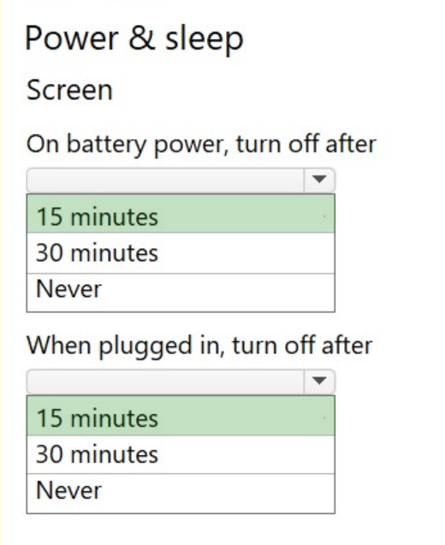

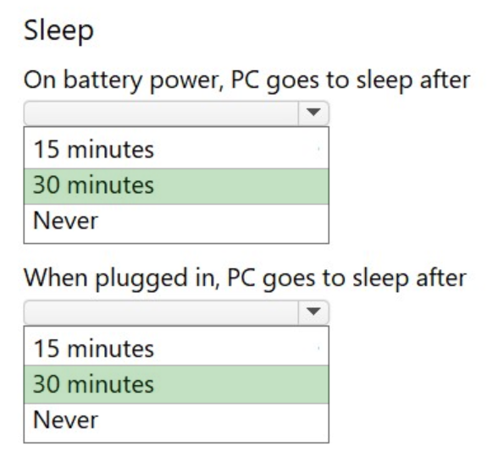

1. A network technician suspects that a client's Windows computer is not correctly connecting to the office network.

To diagnose the issue, the technician runs the ipconfig command on the client's computer.

Which two pieces of information can the technician expect to obtain by running this command? (Choose two.)

1. The encryption type used by the Wi-Fi network.
2. The IP address assigned to the computer.
3. The wireless network SSID.
4. The firewall settings currently applied.
5. The default gateway address configured on the computer.
6. Which document outlines a commitment between an organization and a customer, including details of the service, the standards the provider must adhere to, and compensation for the successful completion of those milestones?
7. Key Performance Indicators
8. Incident Report
9. Service Level Indicator
10. Service Level Agreement
11. 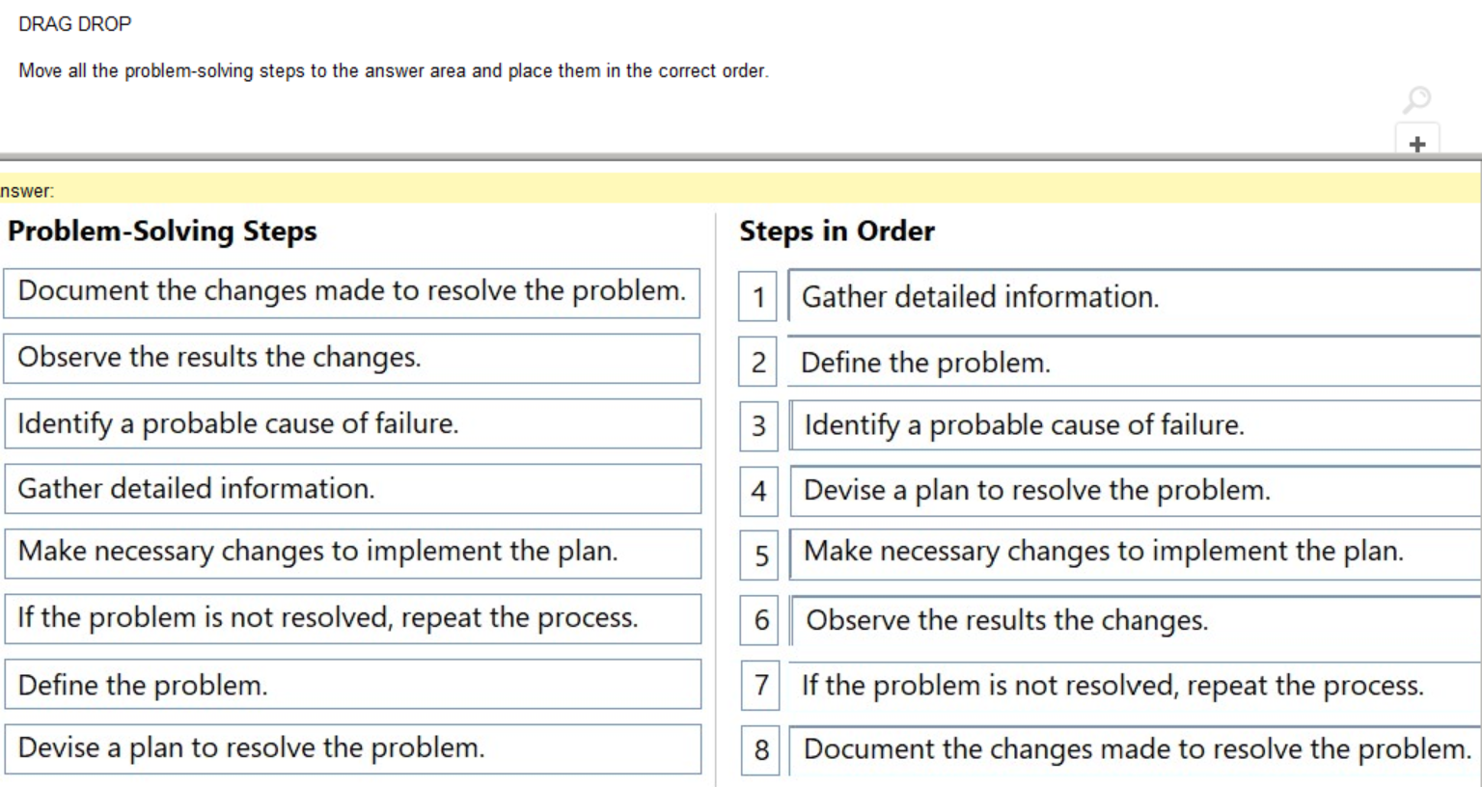Move all the problem-solving steps to the answer area and place them in the correct order.
12. An office uses a DHCP server for all computers on the network. A user calls to report problems connecting to the network. You discover that the computer has been configured with a manual IP address.

Which two possible negative effects could this have? (Choose two.)

***Note:*** You will receive partial credit for each correct selection.

1. Another user might lose network connectivity.
2. The PC may experience a failed ping test to its own IP.
3. The PC may lose complete access to the network.
4. The PC may connect to a different DHCP server.
5. 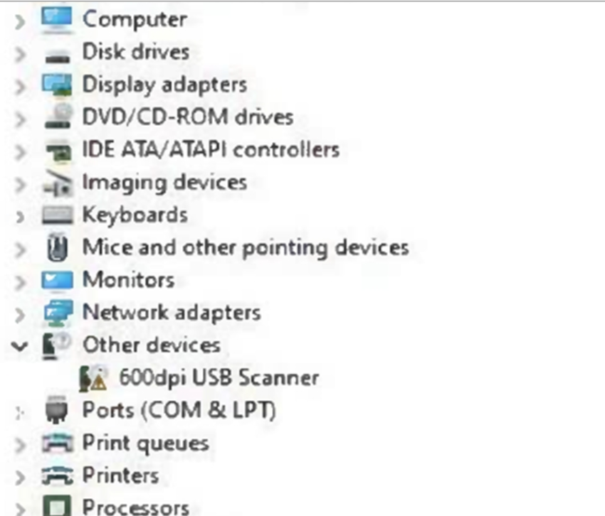A customer cannot scan documents and pictures to a Windows laptop. When you open Device Manager, you see the 600dpi scanner listed under **Other devices**, as shown in the image.

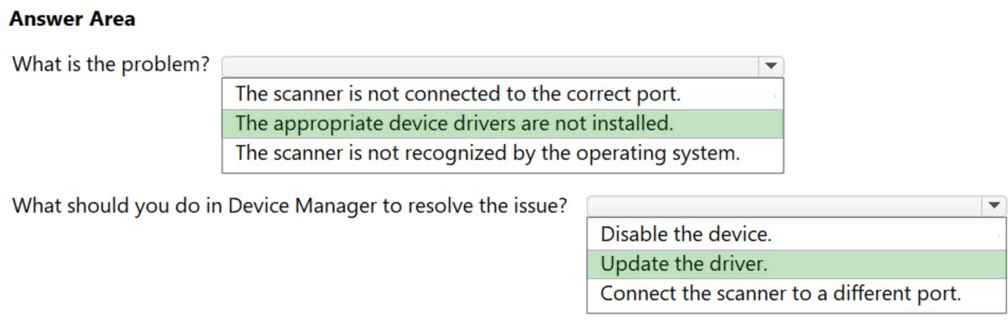

1. A user needs to reset their password based on feedback after a security concern.

You want to provide an example of a strong password to the user based on the following company guidelines shown:

* Must have 8 to 15 characters
* Must contain lowercase letters
* Must contain at least 2 numbers
* Must begin and end with a letter
* Only special characters that can be used dash (-), underscore (_), hashtag (#), and at sign (@)

Which password could you use as an example?

1. dkku546@
2. j546h!Gg
3. ywm546q
4. mkn546#f
5. When researching a technical issue and updating the internal documentation, what is the best approach to ensure the information you retrieve is accurate and reliable?
6. Only use information from personal blogs.
7. Select the first\top website that appears in the search results.
8. Ask a co-worker for their opinion on the search results.
9. Verify information using multiple sources.
10. A user calls help desk to report that they cannot connect to the company’s internal WiFi network.

The help desk technician is following the problem-solving process to resolve the user’s issue. After defining the problem and gathering detailed information, the technician suspects the most probable cause of the issue is a misconfiguration in the user’s network settings.

What should the technician do next?

1. Implement a plan by changing the user’s network settings to match the company standard.
2. Resolve the issue by restarting the wireless access point.
3. Document the problem and solution in the company’s IT knowledge base.
4. Consider the probable cause for the failure by checking whether other users are affected.
5. You receive an email request for personal information.

You need to make sure you are working with the right individual to avoid a social engineering attempt.

Which step should you take?

1. Respond to the email request from the individual to ask them for personal information.
2. Allow the individual to volunteer to share identity information.
3. Use company approved methods to confirm the individual's identity.
4. Share personal account information and ask the individual to confirm it.
5. 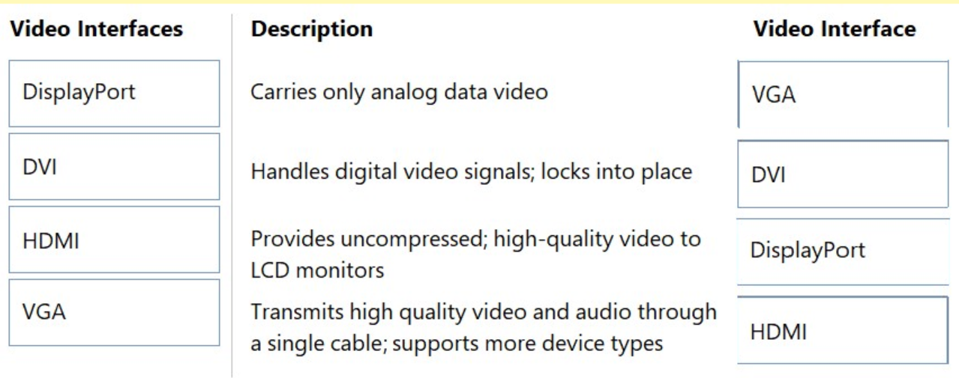
6. Joe calls in to report internet outages. A customer service technician enters the trouble ticket shown below. Review the trouble ticket below and classify which parts of the ticket follow documentation best practices.

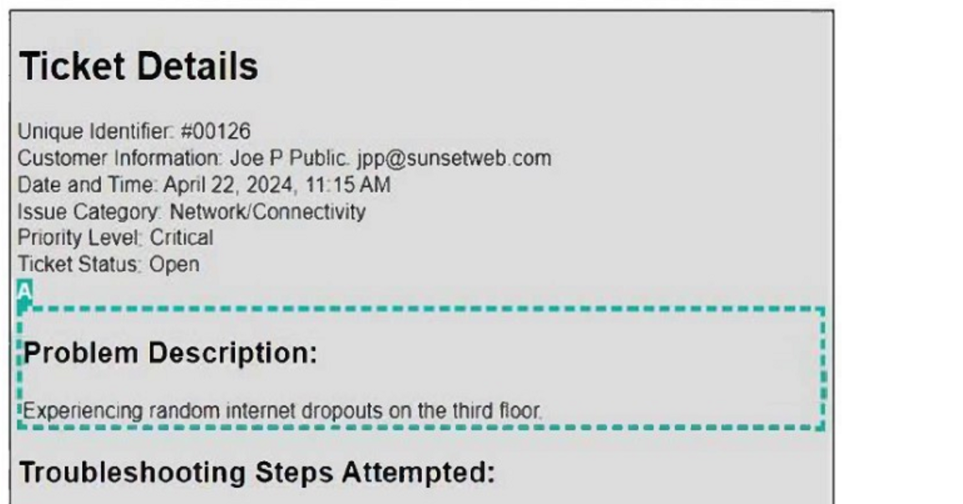

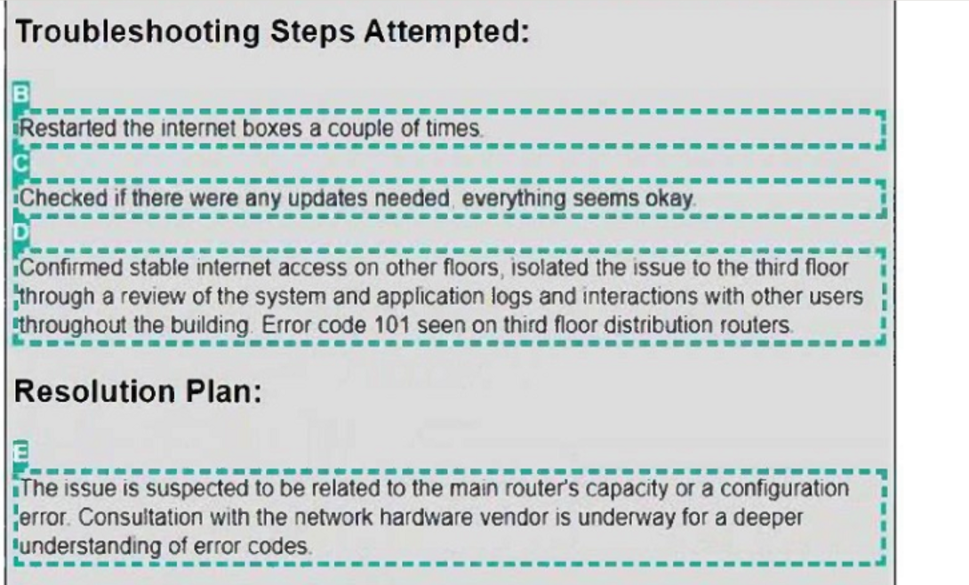

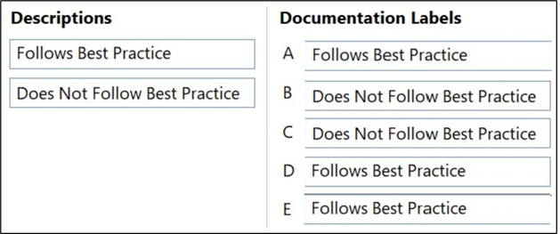**Answer Area**

1. John indicates that he cannot edit the file Test.docx, which is stored on a network shared drive. John can access and edit other files on the shared drive. You review permissions for the file and see the permissions shown in the following screenshot.

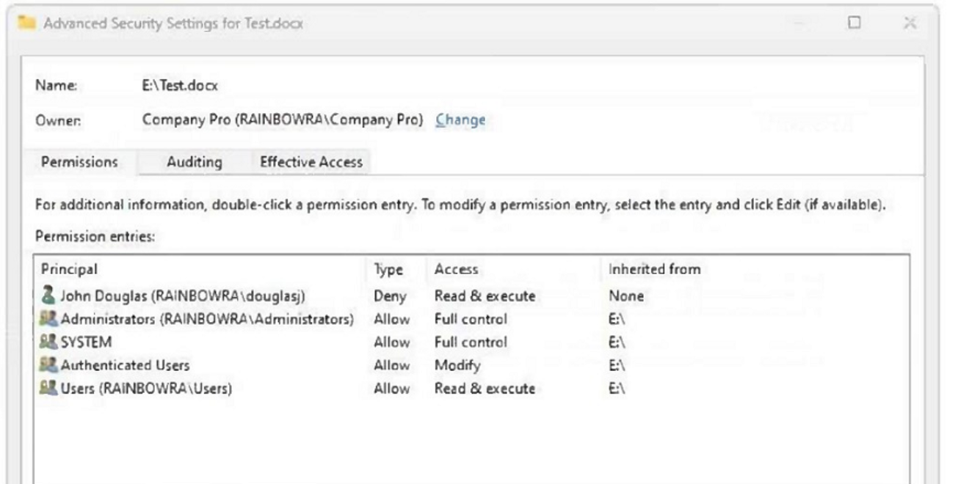

Which change will allow John to access and edit the Test.docx file, while retaining account-level control?

* 1. Move the file to a different folder on the same shared drive.
  2. Modify the NTFS permissions on the file to allow read & execute.
  3. Modify the share permissions on the file to give John full control.
  4. Tell John to modify the NTFS permissions on the file to allow read & execute.

1. A customer copied the APK file for an app from their Windows laptop to the Documents folder on their Android phone. The customer needs help installing the app on the phone.

You need to configure the phone to allow installation of unknown apps.

Which option should you choose?

Select the correct option in the answer area.

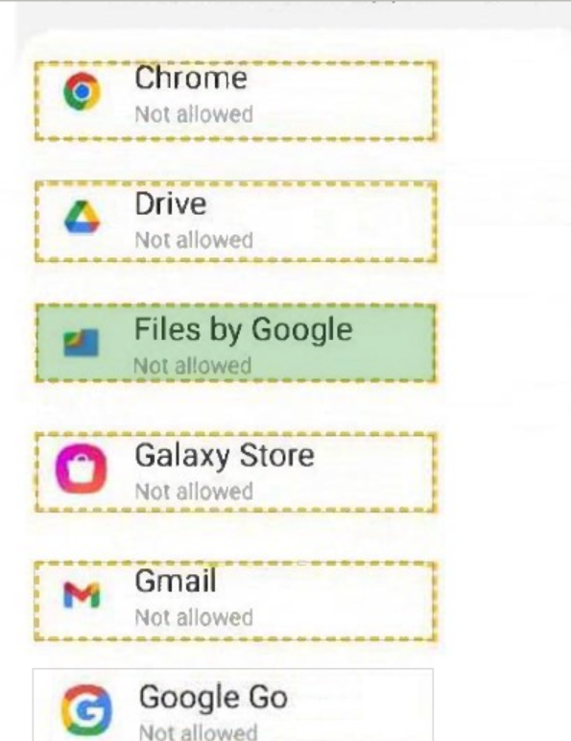

1. Move each help desk term from the list on the left to the scenario it describes on the right.

You can use each option once, more than once, or not at all.

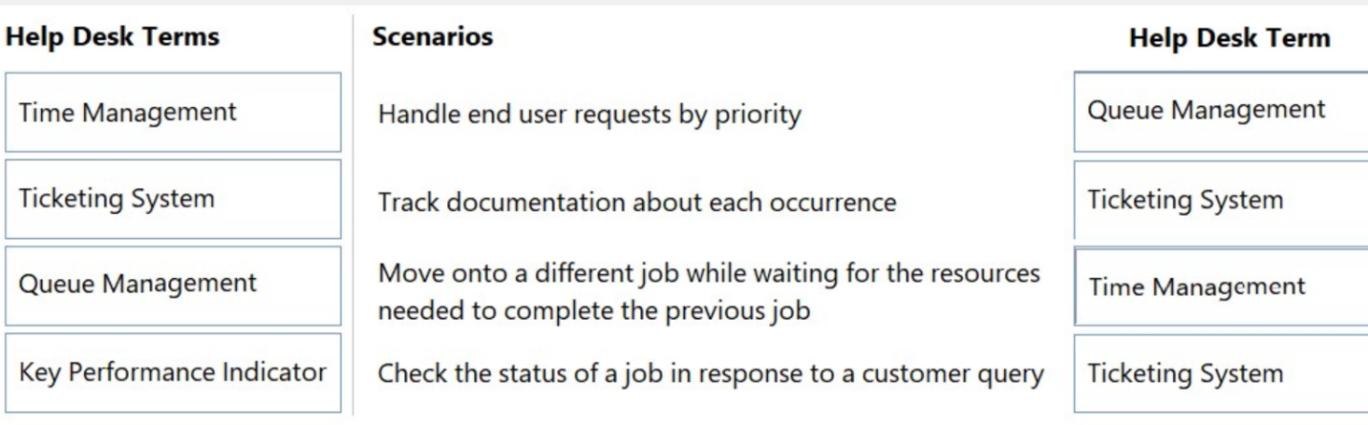***Note:*** You will receive partial credit for each correct response.

1. Which three individual pieces of information are personally identifiable information (PII) and should be protected to safeguard an individual's privacy? (Choose 3.)  
   **Note:** You will receive partial credit for each correct selection.
2. Marital status
3. Finger print
4. Email Address
5. Date of birth
6. Gender
7. Race